TADDINGTON/PRIESTCLIFFE PRIMARY SCHOOL
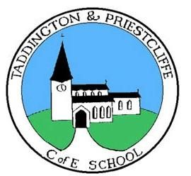
School Lane,

Taddington,
Nr Buxton,
Derbyshire
SK17 9TW

Executive Headteacher: Mr J Handley Tel: (01298) 85278 e-mail: executivehead@taddingtonpriestcliffe.derbyshire.sch.uk
Head of School: Mrs E Chapman Tel: (01298) 85278 e-mail: headofschool@taddingtonpriestcliffe.derbyshire.sch.uk

Wrap around care fees
 | Monday | Tuesday | Wednesday | Thursday | Friday
Breakfast club | £3.50 |  |  |  | £3.50
After School Club | £3.50 | £3.50 |  | £3.50

