The Literary Curriculum Year 5/6 Curriculum Map Cycle A
Theme/Term | Crime & punishment Autumn 1 |  |  |  |  |  |  |  |  |  |  |  | Sprites & spirits Autumn 2
Planning  Sequence/  Spelling  Seed Text | 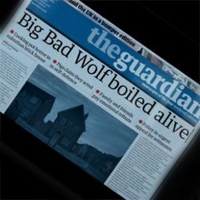  The Three  Little Pigs  Project  The Guardian |  |  |  |  |  | 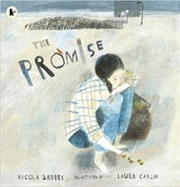  The  Promise  Nicola  Davies |  |  |  |  | Science:  Space | 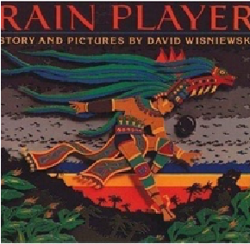  Rain Player  David  Wisniewski |  | History: The  Mayans | 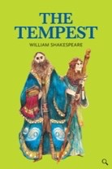  The Tempest  William Shakespeare |  |  |  | History: Ancient  Greece
Length | 12 sessions, 2+ weeks |  |  |  |  |  | 10 sessions, 2 weeks |  |  |  |  |  | 15 sessions, 3 weeks |  |  | 14+ sessions, 3 + weeks
Outcomes |  | Discussion texts News reports, persuasive speeches, interview scripts, diaries, debates, narratives |  |  |  |  | Sequels to continue the cyclical story Experimentation with figurative language, reports |  |  |  |  |  | Analytical essays about The Maya Instructions, posters, missing scenes, diaries, newspapers, debates |  |  | Playscripts  Setting descriptions, character descriptions, diaries, dialogue
Theme/Term | Affirmation & e |  |  |  |  |  | quality Sp | ring 1 |  |  |  |  | Legends, folklore & fairytales Spring 2
Planning  Sequence/  Spelling  Seed Text | 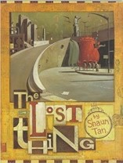  The Lost Thing Shaun Tan |  |  |  | 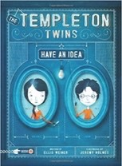  The  Have  Ellis |  | Templeton T an Idea  Weiner | wins: |  |  |  |  |  | 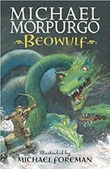 |  | OR Beowulf  Michael  Morpurgo | 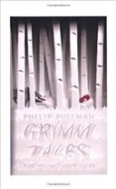  Grimm Tales for  Young and Old  Phillip Pullman
Length | 16 sessions, 3+ weeks |  |  |  | 15 sessions, 3 wee |  | ks |  |  |  |  |  |  | 15 sessi |  | ons, 3 weeks | 15 sessions, 3 weeks
Outcomes | Own version fantasy narratives  Diaries, formal letters, adverts, character and setting descriptions, nonchronological reports |  |  |  | Own version adve Character analysis, entries, informal lett |  | nture narrati opposing diar ers, own cha | ves y pters |  |  |  |  |  | Own ver  Letters of dialogue, scenes, |  | sion legends  advice, diaries,  descriptions, action obituaries | Own version traditional tales Retellings, character studies, monologues, character comparisons
Theme/Term | Lessons from h |  |  |  |  |  | istory Su | mmer 1 |  |  |  |  |  | Solving mysteries Summer 2
Planning  Sequence/  Spelling  Seed Text |  |  |  | 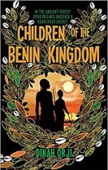  OR  Children of the  Benin  Kingdom  Dina Orji |  | History:  Benin | 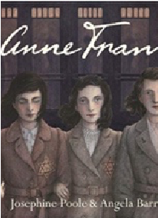 | Anne  Frank  Josephine  Poole |  | History:  WW2 |  | History:  WW2 | 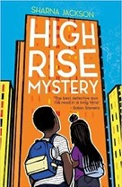  High Rise  Mystery  Sharna Jackson |  |  |  |  |  | 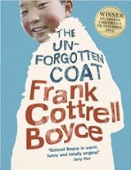  OR The  Unforgotten  Coat  Frank Cottrell  Boyce
Length |  |  |  | 15 sessions, 3 weeks |  |  | 10 session | s, 2+ weeks |  |  |  |  | 15 sessions, 3 weeks |  |  |  |  |  | 15 sessions, 3 weeks
Outcomes | Ne |  |  | Non-chronological reports  Informal letters, diaries, survival guides, eyewitness reports, story summaries |  |  | Newspape  Letters, sho extended di obituaries, | r articles  rt descriptions,  ary entries, opinion pieces |  |  |  |  | Extended stories Character  & setting descriptions, police  & newspaper report, dialogue, persuasive letters |  |  |  |  |  | Own version narratives Diaries, explanations (sci experiment), dialogue, nonchronological reports
Ó The Literacy Tree

The Literary Curriculum Year 5/6 Curriculum Map Cycle B
2022/2023
Theme/Term | Journeys & migration Autumn 1 |  |  |  |  |  |  |  |  | Conservation & preservation Autumn 2
Planning  Sequence/  Spelling  Seed Text | 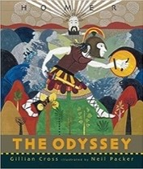  The Odyssey Gillian Cross |  | History: Ancient  Greece | 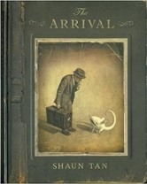  The Arrival Shaun Tan |  |  |  |  | History:  Britain | 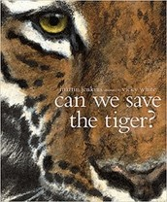  Can We Save the Tiger?  Martin Jenkins |  | 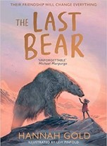  The Last Bear Hannah Gold
Length | 20 sessions, 4 weeks |  |  | 17 sessions, 3+ weeks |  |  |  |  |  | 15 sessions, 3 weeks |  | 15 sessions, 3 weeks
Outcomes | Epic stories Speeches (proclamation, persuasive, soliloquy), dialogue, missing scenes, postcards, adverts |  |  | Extended own version narratives  Letters, lists of rules, character descriptions, diaries, short playscripts, short reports, guides |  |  |  |  |  | Discussion texts  Letters, explanations, persuasive posters, & speeches, simple poems |  | Newspaper article  Character profile, dialogue, monologue, logbook entry, scientific report
Theme/Term |  |  |  | Inspiration & a | ctivism Spring 1 |  |  |  |  | Dystopian worlds Spring 2
Planning  Sequence/  Spelling  Seed Text |  |  |  | 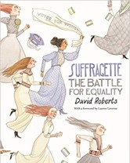  Suffr  Battl Davi | agette: The  e for Equality d Roberts | History:  Suffragettes | 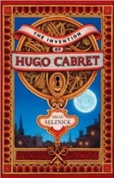  OR The Invention of Hugo  Cabret  Brian Selznick |  |  | Robot Girl  Malorie Blackman | Science:  Robots |  | 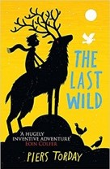  OR The Last Wild Piers Torday
Length |  |  |  | 10 sessions, 2 weeks |  |  | 17 sessions, 3+ weeks |  |  | 15 sessions, 3 weeks |  |  | 16 sessions, 3+ weeks
Outcomes |  |  |  | Persuasive campa  Formal letters, diari arguments, speech  reports | igns  es, balanced es, short news |  | Biographies  Diaries, journalistic writing, flashback narratives, speeches, discussions, letters, film critiques |  |  | Science-fiction narratives Discussions, debates, dialogue, character comparisons, reviews |  |  | Own version dystopian narratives Posters, retellings, formal reports, character descriptions, diaries, formal letters
Theme/Term | Fate & fortune Summer 1 |  |  |  |  |  |  |  |  | A Sense of Place Summer 2
Planning  Sequence/  Spelling  Seed Text | 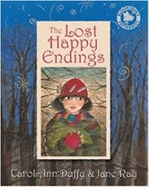  The Lost  Happy  Endings Carol Ann  Duffy |  |  |  | 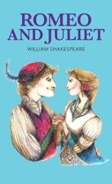  Romeo and Juliet  William  Shakespeare |  |  |  |  | 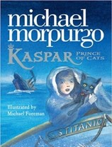  Kaspar, Prince of Cats Michael Morpurgo |  | 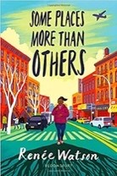  Some Places More Than  Others  Renee Watson
Length | 15 sessions, 3 weeks |  |  |  | 15 sessions, 3+ weeks |  |  |  |  | 15 sessions, 3 weeks |  | 10 session, 2 weeks
Outcomes | Alternative perspective prequels -  Newspaper reports, extended responses to a text |  |  |  | Playscripts  Diaries, letters, narratives, character descriptions, balanced arguments |  |  |  |  | Newspaper articles  Character descriptions, reports, letters, advertising leaflets, balanced reports |  | Poems with similar structure  Summaries, analysis and performances
Ó The Literacy Tree

