The 12 Pillars
Teaching and Learning handbook
J Handley 2022/23
Dove Holes Primary. Taddington Primary. Peak Dale Primary

Contents
The 12 Pillars: Introduction 2

The Plinth: Detail Matters 4

Pillar 1: We are passionate about our subject 6

Pillar 2: We use curriculum maps 7

Pillar 3: We plan for learning 9

Pillar 4: We demand beautiful work 10

Pillar 5: We use feedback and marking dialogue 11

Pillar 6: We celebrate learning 13

Pillar 7: We have exemplary routines 14

Pillar 8: We scaffold learning 15

Pillar 9: We question to deepen to the limit 16

Pillar 10: We use AFL to reshape learning 19

Pillar 11: We have sparkling classrooms 20

Pillar 12: We are all teachers of eloquence 21

Student Commitment – BE BRIGHT 23

Teacher Support CPD 24

Recommended Reading 25

12 Pillars: Our Agreed Expectations Self-Assessment 26

Subject Leadership- Release time and responsibilities 28

“Learners display the confidence and have a breadth of knowledge and range of skills to stand as equals in any circle for any opportunity”
Federation Vision

Teaching and learning is the main priority within the Federation. There is no other area, objective or outcome that is more important than learning. It is our “raison d’être”.

Education Philosophy

“There is only one 21st century skill. And that is the ability to act intelligently when you are faced with a
situation for which you have not been prepared”

Seymour Pappert (1993)

Our approach to this challenge is founded upon our Curriculum Gifts, Bucket List and Life skills. We believe that high levels of academic attainment come as by-products of teaching to our Gifts rather than as an end in themselves.

The 12 Pillars – how we teach

These exemplify what a Federation teacher is. They can be observed by any visitor, in any lesson. These are our 12 Pillars of exceptional teaching.

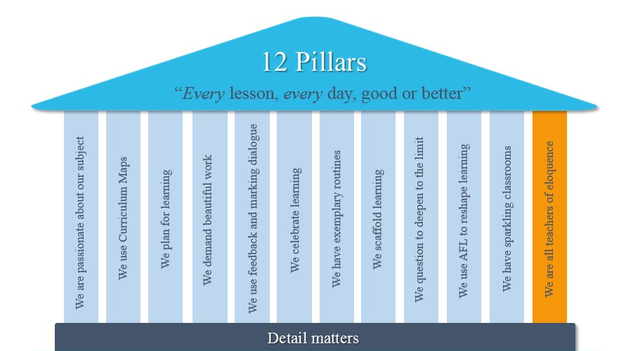

Our Expectation

Every lesson, every day, good or better.

Know Why

Critical to achieving our aims and vision is that teachers know the rationale behind each of the 12 Pillars and the tools; not just the process.

Teacher Craft and routines – the tools to enable our philosophy

For clarity, the 12 Pillars is divided into:

- Federation expectations – teaching tools we all do 100%, no excuses
- Federation Brilliant Practice – teaching tools that from our experience work best with our children

The 12 Pillars has been created by all of our staff who are currently here and have worked here in the past as well as from leading edge research and practice. It will continue to evolve. It is a living document.

Plinth: Detail Matters

Continually using and teaching these routines has been the bedrock of our improvement. Every teacher must master these as their first priority as everything else is built upon this foundation.

Classroom Management
Federations expectation

Following the Culture for Learning golden rules helps to ensure consistency across the school and a good learning environment throughout.

- Plan
- Praise
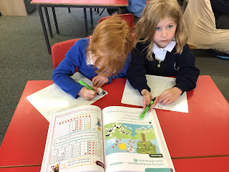
- Employ non-verbal techniques
- Get your instructions followed
- Focus on the behaviour, not the person
- Issue reprimands calmly without emotion
- Never, ever engage in an argument
- Never allow the learning of the many to suffer at the hands of a few
- Reflect after each lesson and ask for support

For more detail on Culture for Learning…read more

Meet and Greet
Federation expectation

Following the meet and greet procedure helps to ensure calm corridors, support for each other and a good solid start to every lesson.
- Meet at the door, smile, warm greeting (new lesson, new start!)
- Children enter in single file calmly
- Check uniform on entry
- Focus task ready for students to start learning immediately
- Complete the register within 5 minutes…
- Students to answer the register with Good morning/afternoon Mr/Mrs/Ms Surname
- Enter late students on the register…

Classroom Dismissal
Federation expectation

Following the classroom dismissal procedure helps to ensure calm exit to every lesson and into the corridors.
Work areas clean and tidy, chair tucked under table
- Silent dismissal in order chosen by teacher
- End of day reflection ‘ what are you proud of today?’ or school prayer

Pillar 1: “We are passionate about our subject”

Passion is contagious; it creates a thirst for learning and it is founded on subject knowledge and engaging content.

Subject Knowledge

“Intellectual digression is at the heart of all great teaching”
Rebecca Clark
Utilising authentic audience to inspire and make our students passionate about their learning.
• Have you harnessed the power of authentic audience?
• Have you seen the work at Hi-Tech High? Read more… http://www.hightechhigh.org/projects/
• Have you read Ron Berger’s book, “An ethic of excellence”? Are his lessons full of passion? Read more,
All of our staff must have the highest of professional standards so that they are outstanding role models for our students and other staff in school.
“Ignite your passion; fuel their dreams!”
All teachers to have, or work towards having, a full mastery knowledge of learning within their specialist subject area. All teachers engage with deep and impactful subject leadership including monitoring, action planning and subject development.
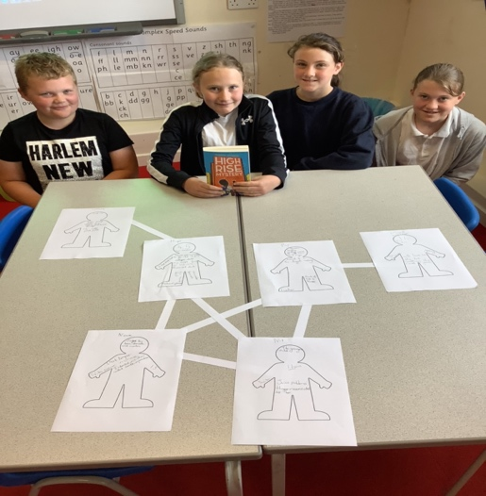
We were interrupted by a news bulletin with shocking news yesterday, so we have joined the super sleuths and are helping to investigate the crime. Our new book is High Rise Mystery by Sharna Jackson. We have been looking through the case files as they have already collected some information.
Today, we were mapping out the characters and their relationships with each other. Nik and Norva - the ones we are helping with the investigation - are sisters.
Taddington Blog post 2022- Authentic audience and purpose

.

•

Consider

•

Can you
skilfully and
intellectual
ly digress in your lessons
?

•

Can you allow your students to go beyond the curriculum?

•

Is your subject knowledge strong enough for children to achieve academic excellence?

Federation expectation

Federation expectation

Federation brilliant practice

Pillar Two: “We Use Curriculum Maps”

Curriculum Maps

Our curriculum maps ( long and medium term plans, knowledge and skill progression documents and knowledge organisers) have been backwards-planned from the Curriculum Gift / curriculum drivers, end of Key Stage 2 requirements, and forward planned from Key Stage 1 and the EYFS. They are pedagogically sound and in a constant state of review and challenge from all members of the school community. They form the basis of subject leader monitoring and improvement planning.

Federation expectation

Every teacher must know their Curriculum Gift and the curriculum drivers and be able to articulate how their curriculum maps delivers these Gifts to our students.

Maps of Learning

We have high quality maps of learning for each unit ( medium term plans and knowledge organisers) which makes planning on a daily basis easier . In order to enhance parental engagement these are shared on the school website. Knowledge organisers are displayed in the classroom which enables excellent practice; retrieval practice and low stakes quizzing. Ways of teaching to be shared across the Federation.
Federation expectation

Teachers teach from the long and medium term plan as well as the knowledge organisers and contribute resources and pedagogical challenge to it.

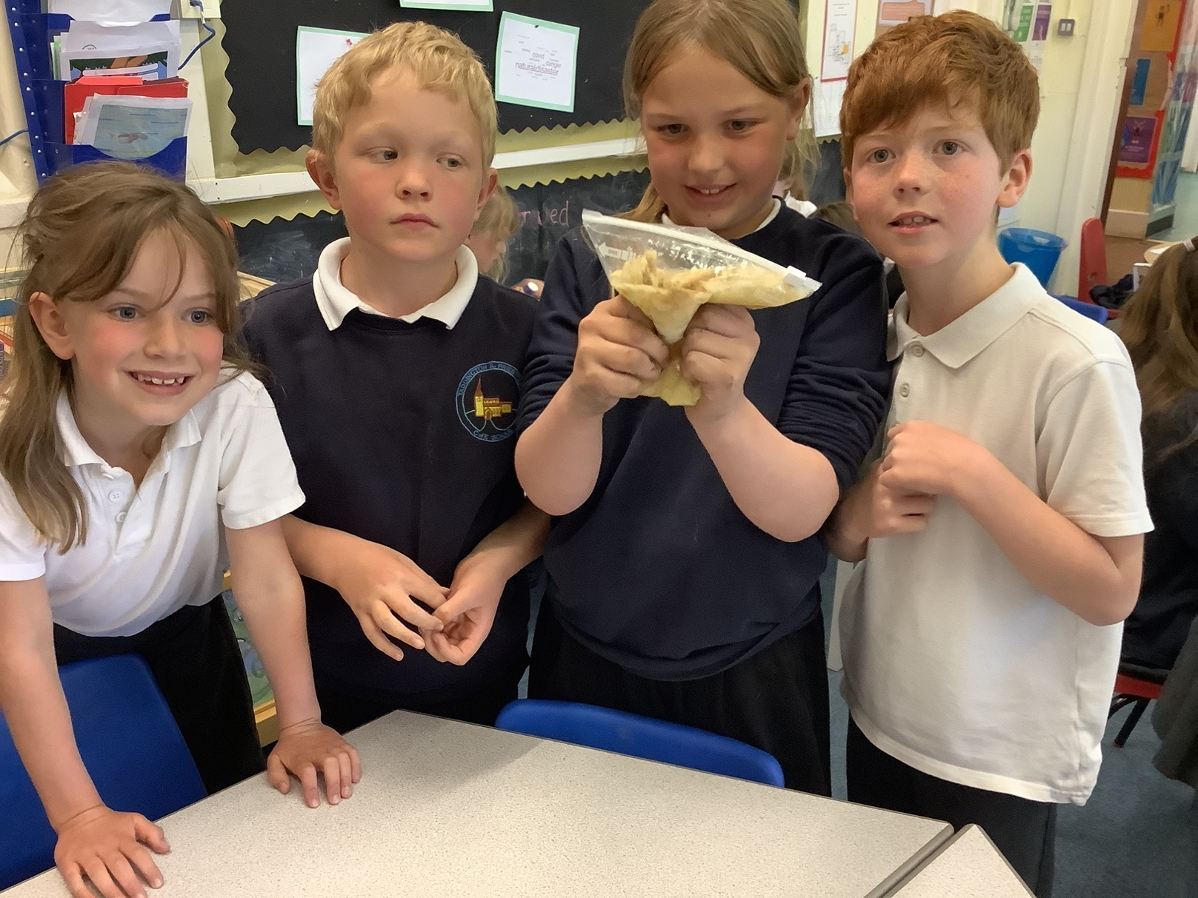
“The curriculum gifts we give to our children…”

A chance to try things out, go wrong & discover and to produce something of their own that makes them go ‘Wow!’

To be surprised by what happens and excited about what they discover when working practically and to ask ambitious questions

Science

To
listen, read

and
communicate with
precision and
passion

English

Geography

Languages

PE

Art

Music

Take part in role-play and drama activities using a foreign language . Read foreign translations of books they know and versions of familiar films and TV shows, to both support language acquisition and intercultural understanding.

To take on positions of responsibility and leadership
within school. Meet local leaders in a range of fields (councillors, faith leaders, business people etc.) and learn about their role and the skills they need to be successful. Have regular opportunities to discuss personal views, ideas and beliefs in an open, trusting environment.

PSHRE

To delight in being stuck and
spotting patterns, simplifying
problems and finding logical
solutions

Mathematics

Computing

D & T

Foster creativity, build
confidence and celebrate
performance

Drama

History

To explore reasoned
argument to understand
who I am, the faiths in
our world and what I
believe

RE

PP

Take part in adventurous, outdoor activities, such as climbing, abseiling, raft building or orienteering. Be introduced to local clubs and training centres through in-school taster sessions. To Play sport in front of spectators (through inter-school events and our Sports Days)

Sing on stage to a (large) audience, both through school productions and projects .Learn to play a musical instrument over an extended period of time, and be given opportunities to develop this further. To perform a large-scale musical with peers, using microphones, staging and costumes.

To have opportunities to use things they have made recognising that their work really is purposeful and practical and to produce something of their own that makes them go,“Wow!” and that is bigger than them!

To develop a sense of historical order and ‘scale’ and to practice the skills of questioning, enquiry, evaluation and interpretation. To understand our past, learn from our mistakes and successes to make a positive impact on our future.

To understand our planet, how we inhabit it and our effect on it and to talk to people who have lived and grown-up in different parts of the world. To explore through walks, visits and fieldwork to parks, shops and other places locally and beyond

To experience the process of ‘being’ an artist, working
on canvas, using an easel, organising, using and caring
for their tools and seeking out new inspiration and receiving feedback from their audience

Pillar 3: “We plan for learning”

Well-planned lessons are the foundation for good lessons on a daily basis. If your classes aren’t engaging, behaving or progressing, then your first port of call is to check your planning, as 95% of the time this is the root of the problem.

Federation expectation

Planning folder ( found on the G-drive ) which contains:
- Curriculum Maps ( long and medium term planning)
- Knowledge organiser and low stakes quiz
- End of unit reflection that shows evidence of planning that reflects systematically on the effectiveness of lessons and pupil learning.
- Assessment data
- Up to date 12 Pillars and home learning letter
- Cycle of planned parental engagement drop ins ( book looks, maths morning, information events)
- Subject leader resources; monitoring and action plan.
- Teacher development plan

Federation expectation

Medium term plans, knowledge organisers and examples of low stakes quizzes must be produced and made available to inspectors for formal inspections by Executive Head and OFSTED and for PGCE/ITT/ISP lesson observations.

Federation expectation

Home learning must be set according to the Home Learning letter and pupils must be responsible for their own home learning folders.

Federation brilliant practice

The very best home learning helps create the independent skills and work ethic students will need for later life when at college, university or in the work place. Home learning needs to be planned for carefully and set in a way that is manageable for the teacher and beneficial for the student. Have you considered?
- Revision and consolidation exercises…( retrieval practice grids)
- Spelling, grammar and comprehension activities…
- Rote learning exercises…( TT rockstars , Numbots)
- Reading…
- Quizzes or the use of online homework platforms…
- Flipped learning…read more
- Independent Projects (IPS)…read more

Pillar 4: “We demand beautiful work”

Improving the quality of the students’ exercise books and products has been a key driver for change within the Federation. The students now know that their learning is valued by their teachers and is checked regularly. They know they are expected to produce work of a high quality. Concentrating on the quality of the books/products will lead to improvements in every classroom within the Federation and as such this pillar is a corner stone and one that shows the quality of learning within the Federation. We have beautiful books.

Federation expectation

Beautiful books:
- Are free from graffiti
- Have full name, subject, year group, class, teacher’s full name, all correctly spelt on printed labels
- Old books are kept in school to show progress over time
- Writing in pencil in all subjects until children have earned a pen licence. Diagrams and maths work is always in pencil.
- Straight lines are drawn with a ruler
- Errors are scored through with one neat line
- Hand-outs are neatly glued in and photographs of learning are displayed in books
- Pupils edit and improve and respond to feedback using a blue pen
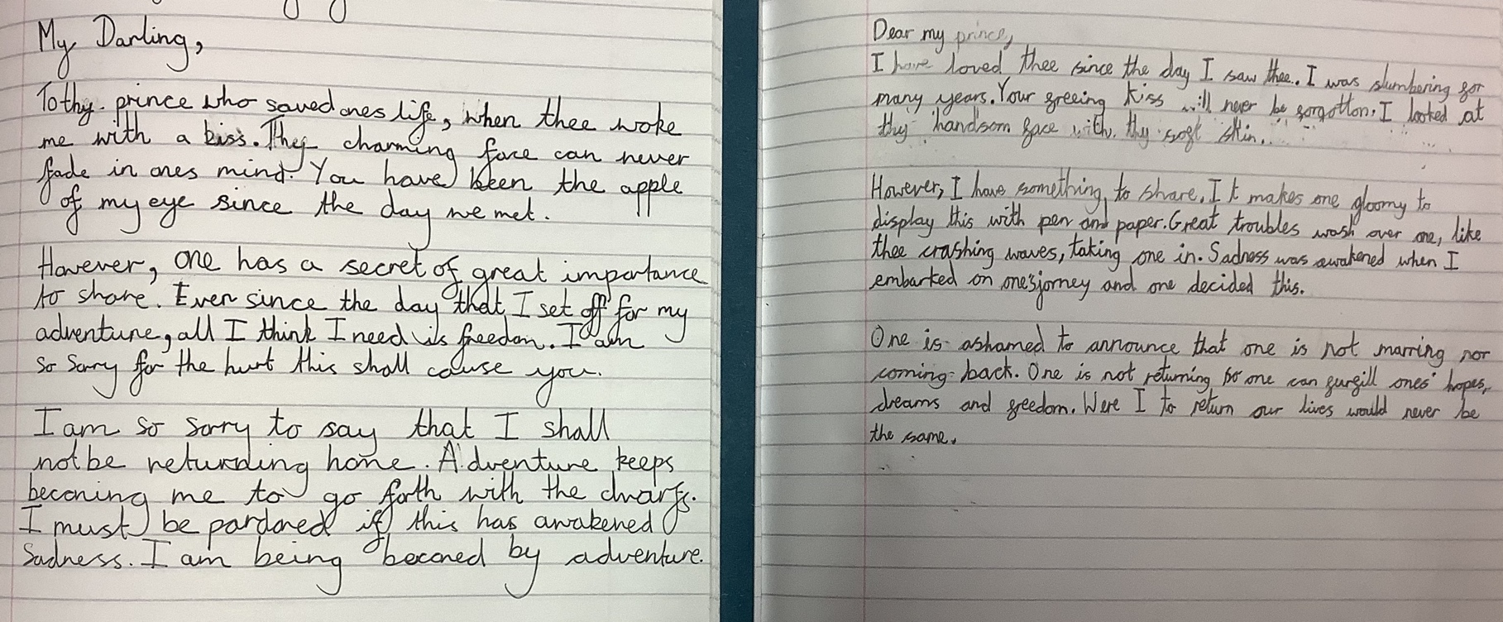

The
very best books

show great learning and progress over time.
They include different
mediums, colour, and formats…

Federation brilliant practice

Pillar 5: “We use feedback and marking dialogue”

Effective marking and feedback is proven to improve the rate of progress for students substantially. Doing this effectively will ensure our students are in the habit of wanting to improve their learning and only accepting the best from themselves. If you spend 5 minutes marking their books, they should be spending longer than that improving their learning. This is a marking dialogue; students are clearly engaging with your feedback and improving their learning.

Federation expectation

Teachers must mark in green pen. The next step symbol should be used for Directed Improvement Task (DIT). Every pupil should have at least one DIT task in each subject each week . In writing, pupils should have one in-margin marked piece of work each week following the marking code ( sp,p, gr etc.) and be given time to make improvements using a blue pen. All other work should be looked at daily and traffic light given by the teacher next to the LO . Monotirng of books that are amber and red will show that the following lesson has been adapted ( further scaffolds, follow up tasks, teacher focus group ) whilst green books will show consolidation, extension or challenge.
Marking as outlined in the marking and assessment policy… read more
If improvements aren’t to be made immediately, an index sticky note must be used to indicate to pupils that they need to complete their improvements.

Federation expectation

Pupil Premium, SEND and target students’ books are to be marked first.

There are several techniques employed by our outstanding teachers to keep on top of marking which include:

Federation brilliant practice

Check the learning in the books at every evening. This is a technique used widely in Primary Schools and is a great technique for new or inexperienced teachers to ensure students are producing enough work, of the right quality and if they have learnt what you wanted them to learn
Federation brilliant practice

Mark as you walk and talk. Carry your green pen, signal that you have given verbal feedback or checked their learning. Indicate when your feedback has produced an improvement. Use the ‘ +, - or =’ sign to indicate that the current piece of work is weaker, stronger or the same standard as the previous and ask the student to suggest why in writing. Hold marking circles in lessons asking children to find evidence of the SC using in margin marking and give self or peer next steps. Use mini plenaries or plenaries for peer or self assessment. Exit point questions and displaying the answers so that books can be piled in red amber or green groups will support with traffic lighting, giving more time for teachers to reconsider the following lesson.
Federation brilliant practice
Multiple drafts. Show improvements in learning by getting students to produce multiple drafts, ending up with the finished piece in best format. This teaches students that one draft is not enough and will help model self-assessment in the longer run.

Pillar 6: “We celebrate learning”
Federation expectation

Students must be rewarded with reference to the school values

Federation brilliant practice
Positive learning is essential to create a culture where our students have many more positive interactions every day than negative. Students that have more positive interactions than negative will see and value the benefit of doing well and so go on to succeed. Utilising excellent learners on your board can help to ensure you have a positive classroom and the students can see the positive interactions.
Federation brilliant practice

Teachers who use a wall or corner of excellence find that their students are very proud of their achievements and this has a very positive impact on learning. Artifacts such as raffle tickets, class mascots or special cushions for pupils in class demonstrate to students the value we place on positive learning.
Federation brilliant practice
Teachers who celebrate the students’ work at Parents Evening find that the parent becomes more engaged with their child’s learning and understands better how their child needs to improve.

Pillar 7: “We have exemplary routines”

Often the difference between a teacher that requires improvement and a good teacher on a daily basis is the implementation of their expectations and daily routines within their classroom. Great teachers have seamless routines that look effortless in the classroom. Teachers who are struggling have routines that are not consistent and not followed consistently by the students. Exemplary routines are the basis for “typicality” and are at the heart of exemplary classroom management.

Federation expectation

Use of 3-2-1-0 / 1,2,3 eyes on me 3,2,1 eyes on you for whole class attention
As a Federation we use this routine after an extended learning sequence in order to bring a task to a halt and gain whole class attention. The technique is designed to give warning and time for students to finish their task or conversations and then to be giving their full and undivided attention to the teacher or another pupil. Adopting this approach across the Federation supports classroom management and consistency in every classroom.

Federation brilliant practice
Whole class Q&A session - expectations
Exemplary expectations and routines are essential to ensure students are listening to the teacher and each other during a Q&A session and actively listening. No hands up ( except to ask a question) Use lolly pop sticks or random name generation so that all learners know that they are expected to think and respond. Talking partners or triads ( pupil A, B, C, : pupil A’s response, pupil B’s response and pupil C synthesises and feedback to the class) encourage full participation.
FFe Federation brilliant practice
Collecting equipment. Students need to be trained how to collect equipment within your classroom quickly and safely
Federation brilliant practice

Transition in to group work or another activity that involves movement
Great routines and expectations when transitioning from one activity to another can make your classroom incredibly efficient and sharp

Federation brilliant practice

Expecting participation: 100%
You need to train your students and build them up to your expectations of participation. Students will gain confidence and reassurance over time when you are consistent, confident and reassuring.

Federation brilliant practice
Becoming “unstuck” Have you challenged and trained your students to use their brain, board, book and buddy before asking you? ( ‘3 before me’)

Pillar 8: “We scaffold learning”

At our schools, we hold the highest of expectations of our students and we pitch to the top, not the middle. We set challenging learning objectives and use our skills as teachers to scaffold the learning so that all students can access the lesson and maximise their progress. It is only by having these high expectations in every class, every day that we will ensure our students can stand as equals.

Federation expectation

The lesson objective will be shared with the students at an appropriate time within the lesson…

Federation expectation

Differentiation is expected in every lesson…read more

Federation brilliant practice

Start every lesson with a review
- Are your students successful straight away?
- Do your students retain the knowledge and information they learnt from their last lesson with you?
- Have you read about how memory works and the need for distributing practice, overlearning and testing frequently? Read more https://pragmaticreform.wordpress.com/2013/11/16/memory/
A key thrust at our schools is for students to retain and recall the skills and content they have been taught. Do not underestimate the power of practice, mastery (practice beyond knowing it) and regular testing. For all children in all classes and subjects phonics, decoding and regular opportunities to link learning with stories, inference and deduction is key. Model reading texts and at times do so incorrectly and ask students to correct you using the correct strategies.
Federation brilliant practice
Use resources to scaffold and support learning within your classroom
- Writing frames / sentence starters
- Speaking frames ( Using Tower Hamlets read more)
- Literacy mats
- Key word cards
Some examples could include:
Use a variety of differentiation in every lesson. Differentiate your lesson with the High Prior Attainers, Mid Prior Attainers, Lower Prior Attainers, SEN and PP in mind. Some ideas include extension activities, challenge activities, prompt cards…

Pillar 9: “We question to deepen the limit”

‘The wise man doesn’t always give the right answers; he poses the right questions’

Claude Lévi-Strauss
‘

Great questioning is a defining skill of a teacher. Time spent crafting your questioning skills will have great impact on the quality of your daily teaching. There are two expected techniques employed at the Federation. With consistency, we will see: participation in lessons improve across the board, and teachers able to assess how much pupils have learned.

Federation expectation

Cold Call… read more here
- All of your students answer all of your questions. Lolly pop sticks should always be used to check for understanding and pupils should all be able to qualify, add to, support or challenge one another.
- Test mastery, regardless of whether pupils offer to tell you
- Increase pace
- All pupils can have their voice heard and feel valued
Federation expectation
No opt out… read more
Turn ‘I don’t know’ into success
Everyone takes responsibility for learning
Promote peer support

However, great questioning is not just about these two techniques. ‘Brilliant Practice’ questioning is used to promote and challenge learning, and stimulate and probe thinking. The techniques below require more advanced skills and preparation, and are part of the most effective teachers’ toolkit. Although many different techniques can be used every lesson, we advise you to choose one or two and become masters at them before moving on to others.

Testing previous learning:

•

Pepper….. watch here

•

Call and Response
…. watch here

Stretching & challenging thinking:

•

Right is right…
watch
here

•

Break it down
… watch here

•

Stretch it …
watch here

•

Question the question…
watch here

•

Pupils Ask
… watch here

•

Exit ticket…
watch here

Federation brilliant practice

Federation brilliant practice

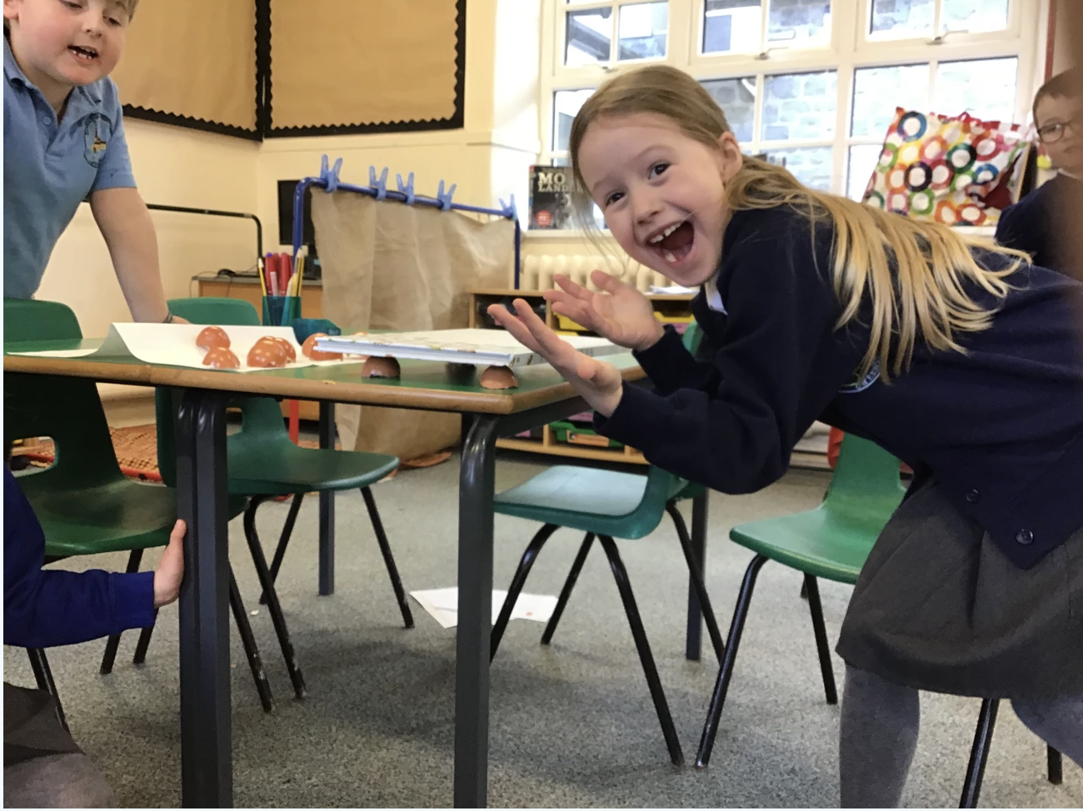

Pillar 10: “We use Assessment for Learning to reshape learning”

Assessment for learning is a continual process that occurs during various interactions within the classroom. The most important aspect is that the teacher uses the information gathered about how well the students are doing to impact their progress positively. This is a key skill of outstanding teachers. They are not just assessing learning, they are then using the information to reshape the learning and ensure maximum progress is achieved.

Federation expectation

Teachers must be acutely aware of where all their learners are in relation to what they are learning.
There are many techniques a teacher can use for formative assessment. When expertly employed, they help the teacher to know exactly where each student is in relation to what they are meant to be learning. These techniques then enable teachers to make decisions or take actions that can reshape the learning if required.
Have you read Dylan Wiliams and Paul Black’s “Inside the black box”?

There are several
techniques employed expertly

by our
outstanding
teachers which
include
:

•

Looking

at their work

over their shoulder and questioning/challenging/correcting

•

Listening

to their discussions/responses

and deciding when and if to intervene

•

Using

m
ini whiteboards

to engage all students and check their understanding

•

Targeting

a group of

students to go through a concept you know they haven’t got
or to push a group further on

•

Employing

mini p
lenaries

to check on progress

•

Using

carefully
-
constructed

hinge q
uestions

to decide which direction you should
take next

•

Using
focus

tasks

to assess what students know already

•

Using
exit tickets

to ascertain what concepts have been understood or perhaps
more importantly, misunderstood

Federation brilliant practice

Pillar 11: “We have sparkling classrooms”

Teachers must have:

•

A broad and balanced curriculum displayed

•

Tidy, professional looking room.

•

Tidy desk
that models best practice for students

•

Examples of excellent work prominently displayed

A
sparkling classroom

is an i
nspirational learning environment…
read more

Table layouts

should be considered to create the right environment for learning. As our
Federation grows, each room will be used more frequently by a variety of teachers and so
the room should be left in a standard layout that all teachers who use the room are aware
of so

that they know what room set up they will be walking in to. There are a variety of
table layouts deployed within the Federation including groups, v’s, straight rows and
Harkness tables
…

Creating
i
nteractive d
isplays

can trigger the curiosity of students
…

Federation expectation

Federation brilliant practice

Federation brilliant practice

Federation brilliant practice

Consider

•

Does your classroom sparkle?

•

Does it provide a model and inspiration for exceptional learning?

Pillar 12: “We are all teachers of eloquence”

Developing eloquence – the art or power of using speech to impress, move or persuade – is essential for our students to be able to stand as equals in any circle, for any opportunity. Eloquent students speak clearly and confidently in class, using Standard English and appropriate vocabulary. All staff are responsible for developing our students’ speaking skills, whether in classroom discussion or in individual conversations.

Federation expectation

Sentence - Students answer questions in full sentences, using ABC sentence starters where appropriate…read more

Federation expectation

Voice - Students speak clearly with enough volume so the whole class can hear first time…

Federation brilliant practice

As we develop our students’ speaking skills over the next year, we will increase the number of expectations in the classroom. Some teachers who are confidently using Sentence and Voice expectations may also choose to focus on:
- Grammar – correcting errors in students’ language to promote the use of Standard English…read more
- Confidence – ensuring students avoid hesitating and using ‘fillers’, have confident body language and sound convincing. Students use subject-specific terminology with confidence…

Federation brilliant practice
There are several activities you can build into lessons which will promote students’ speaking skills.

Talk Partners

Sort It

Talking Points

Information Gap

Diamond 9

Line Up

Envoy

Snowball

Reporters/Hot Seat
- What’s the question?
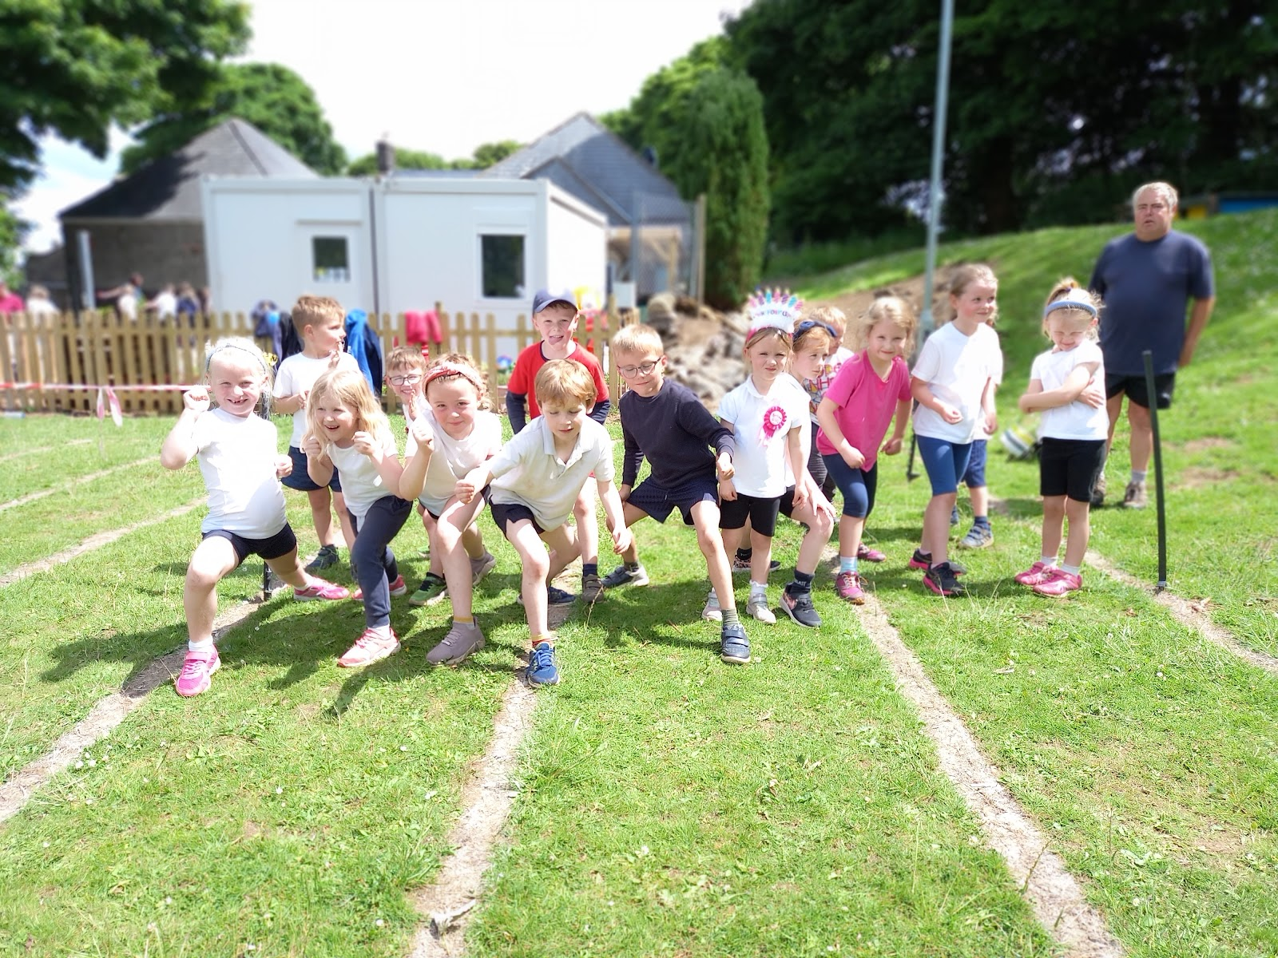

Student Commitment
BE BRIGHT

Our Commitment to ‘Be BRIGHT’

Our commitment | Key foci | What we do
B  BEAUTIFUL | BOOKS | We take pride in our books and work; our books are a reflection of ourselves and our attitudes to learning.
 | UNIFORM | We are proud of our appearance and strive to be ambassadors for our school and community.
 | ELOQUENCE | We know our speech and body language create an impression of us to others; we interact politely with others
R  RESILIENCE | ‘BOUNCE-BACK-  ABILITY’ | We greet failure as an opportunity to learn, and try again undaunted
 | PERSEVERANCE | We keep going, even when it proves challenging
 | ACHIEVEMENT | We celebrate our successes and realise that the best rewards are earned, not given
I  INDEPENDENCE | ORGANISATION | We are prepared for each day and plan in advance to help our lives run smoothly
 | INTEGRITY | We are honest and stay true to our moral code
 | RESPONSIBILITY | We accept ownership of our actions and behaviours, and their consequences – both positive and negative
G  GROWTH  MINDSET | HOPE | We have a positive attitude to life; we firmly believe that things can change through our efforts
 | ASPIRATION | We believe that our success and potential is not fixed; we actively seek to broaden our horizons and improve ourselves
 | COURAGE | We are brave enough to push ourselves, take a positive risk, and go beyond our comfort zone
H  HEALTHY LIVES | HEALTHY BODY | We exercise, and eat and drink healthily, to maximise every minute of our lives
 | HEALTHY MIND | We understand that our mental attitude is crucial to our health and success; we sleep well and develop mental habits to keep us strong
 | HEALTHY RELATIONSHIPS | We know that the people around us make us strong and successful; we understand how to recognise and develop positive relationships
T  TEAM PLAYERS | RESPECT | We think of others before ourselves and are aware of others’ needs
 | LEADERSHIP | We engage those around us in a positive goal, and hold others to account when necessary.
 | COMMUNITY | We realise we are part of a global human community – supporting our school, local, national and global causes

Teacher Support: Continual Professional Development (CPD)

Recommended Teacher Reading

Within the Federation, we strongly encourage research and reflective practice. We purchase books for staff to read so they can engage with literature and read around their subject. Ask your fellow professionals what they are reading and engaging with. Talking about pedagogy will help make us all better practitioners. Happy reading!

Title | Author | Review
Practice Perfect | Doug Lemov | This book will help you take more control over your own classroom practice.
Teach Like a  Champion | Doug Lemov | A great manual of teaching. This book outlines the 49 methods used by excellent teacher and emphasises the need to practise and embed our techniques systematically.
Full on  Learning | Zoe Elder | An inspirational book. Helps you to understand how students learn and how you can promote independent learning within your lessons.
Visible Learning | John Hattie | Hattie is an educational legend! This book examines learning from a range of viewpoints and focuses on what improves learning and the processes that underpin this.
Essential  Classroom  Motivation | Ian Gilbert | Ian Gilbert wrings out all he has learnt about classroom motivation; the things that make a real difference in the classroom.
The Lazy  Teachers  Handbook | Jim Smith | Some very good practical ideas to make students work harder than teachers!
An Ethic of Excellence | Ron Berger | This book will get you passionate about students producing the highest quality work. You will suddenly realise the benefits of your feedback and marking and get inspire you to get your students being junior experts within your subject area.

12 Pillars – Our agreed expectations
 |  |  |  | 1 | 2 | 3 | 4
1. The Plinth - Details Matter
- Classroom management – golden rules
- Meet and Greet
- Classroom dismissal

2. We are passionate about our subject
- Full knowledge of the National curriculum for the year groups that you teach
- Professional standards, role models for our students

3. We use curriculum maps
- Know curriculum gift
- Teach from medium term planning and knowledge organisers and contribute resources and pedagogical challenge to it

4. We plan for learning
- Planning folder
- Medium term plans and knowledge organisers for formal inspections
- Assessment data ( foundation subjects)
- Teacher development plan
- End of unit reflection
- Home learning letter

5. We demand beautiful work
• Beautiful books

6. We use feedback and marking dialogue
- Green pen and next step symbol used for Directed Improvement Tasks
- Improvements made by students in blue pen
- Pupil Premium/SEND/ target children books marked first

7. We celebrate learning
• Students rewarded using school values and brought to life with artifacts ( raffle tickets, name on board, class perks)

8. We have exemplary routines
• Use of 3-2-1-0 / 1,2,3 eyes on me for whole class attention
- No hands up except to ask a question

9. We scaffold learning
- Lesson objective shared appropriately during the lesson
- Differentiation in every lesson

10. We question to deepen to the limit
- Cold call – use of lolly pop sticks
- No opt out

11. We use AFL to reshape learning
• Acutely aware of where all learners are in relation to what they are learning

12. We have sparkling classrooms
- Tidy, professional room (including desk)
- Examples of exceptional learning prominently displayed
- Broad and balanced curriculum evident
- Photographs , diagrams and written outcomes
- Promoting a love of reading is evident with the learning environment

13. We are all teachers of eloquence
- Sentence – students answer in sentences, using ABC sentence starters
- Voice – students speak clearly with enough volume so that the whole class can hear
- Subtle corrects to speech and grammar are given through the ‘reforming technique’
- Vocabulary is prominently displayed and discrete lessons enhance pupils understanding of tier 2 and 3 words.

1 | 2 | 3 | 4
I do this every time | I do this most times | I do this sometimes | I don’t do this very often

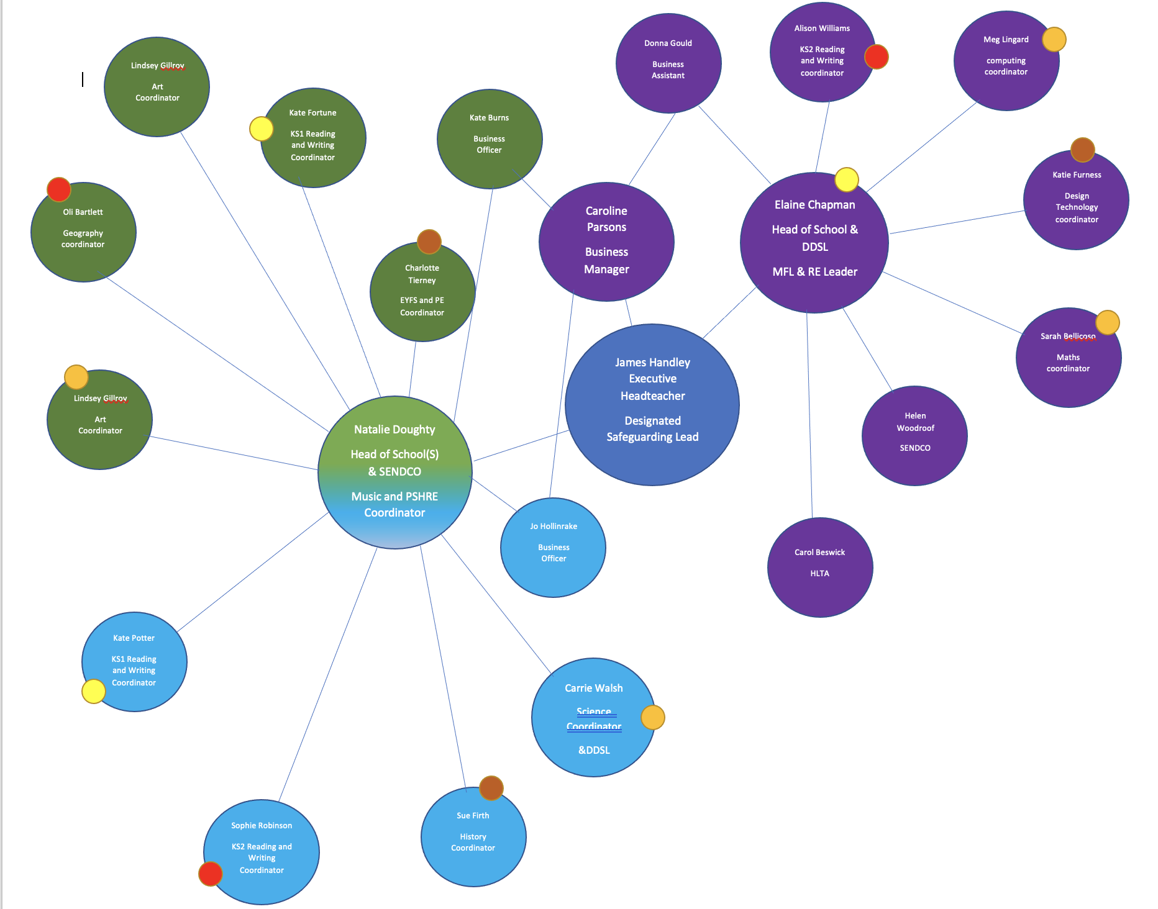
Subject leadership

Across the Federation, each teacher is responsible for the monitoring and development of subject areas. Although the challenge of working across schools will test our communication, this offers teachers an opportunity to refine their knowledge and skills in relation to fewer subjects becoming a true expert. Regular release time will provide teachers with an opportunity to; visit classrooms beyond their own school, develop leadership competencies and to learn from the very best practice within the Federation. The coloured circles group staff so that they can feedback to link teachers in each school who can in turn work with the Head of School and staff team implement action plans.

The below guide illustrates the subject leader process as well as the roles and responsibilities of the subject leader, the link member of staff and the Head of School who all play a fundamental role in driving improvements across the curriculum.

The subject leader process
Analyse, Build, Cultivate.

Through high levels of collaboration and frequent communication, it is expected that the below process will drive significant improvements in the quality of education within all schools part of the Federation.

All teachers are subject leaders as such the following aspirational teaching standards for those earlier on in your career relate to the subject leader role.

M3-M5 | M5-M6 | Upper pay range
Develop units of work that inspire, motivate and challenge pupils and consistently deliver lessons that inspire, motivate and challenge most pupils. | Lead on developing units of work that inspire, motivate and challenge pupils. Support staff by sharing good practice through lesson observations/learning walks. | Lead on adapting the curriculum model for the key stage/whole school in ensuring that expectations are high across the key stage/whole school and that students are inspired and motivated.
Support all key stage /whole school members to ensure that pupils are actively engaged with their targets and progress to ensure that pupils achieve a minimum of expected progress and that some achieve beyond. | Lead on intervention strategies across the key stage/whole school to support good progress and outcomes by all pupils to ensure that they achieve a minimum of expected progress and that many achieve beyond. | Lead on intervention strategies across the school to support good progress and outcomes by all pupils to ensure that they achieve a minimum of expected progress and that most achieve beyond.Monitor year group/KS attainment and plan support for pupil targets across the year group or key stage.
Demonstrate good subject knowledge and an understanding of regional and national developments in the specific subject area. | Regularly lead in meetings, share subject knowledge/up to date changes in the curriculum and developing schemes of work across school . | Demonstrate outstanding subject knowledge and impact on whole school curriculum decisions by contributing to curriculum planning.
Teachers consistently deliver teaching and learning in line with Ofsted grading Good with Outstanding features. Regularly share examples of good practice through teaching and learning programmes. | Teachers consistently deliver teaching and learning in line with Ofsted grading Good or Outstanding. Facilitate the leadership of coaching strategies within the key stage/across school. | Teachers consistently deliver teaching and learning in line with Ofsted grading Good or Outstanding. Facilitate the leadership of coaching strategies across the school.
Share effective differentiation techniques within the key stage/across school in order to ensure that all sub groups of pupils achieve their potential. | Support the school or key stage by developing methods of meeting the needs of different pupil sub groups. Support whole school or key stage with producing various strategies for progression. | Support the school by developing methods of meeting the needs of different pupil sub groups. Produce various strategies for progression across the school.
Ensure that quality tracking of pupil attainment and achievement informs future planning to promote rapid progress of pupils. | Take an active role in the whole school or key stage to improve tracking and assessment. Support other in using assessments to inform future learning and to raise attainment and achievement. | Take an active role across the school to improve tracking and assessment. Support other staff in using assessments to inform future learning and to raise attainment and achievement across the school.
Behaviour management strategies are embedded which ensure a consistent positive climate for learning within the classroom, which will impact on attainment and progress. Share these strategies with other members of the school. | Behaviour management strategies are embedded within the classroom, which ensure a consistent positive climate for learning.  Lead on developing a wide range of strategies to ensure a consistent positive climate for learning across the whole school or key stage, which will impact on the attainment and progress of all pupils. | Behaviour management strategies are embedded within the classroom, which ensure a consistent positive climate for learning.  Lead on developing a wide range of strategies to ensure a consistent positive climate for learning across the school, which will impact on the attainment and progress of all pupils.
Regularly share initiatives at staff meetings in order to impact on attainment and progress. | Regularly lead on whole school or key stage initiatives to impact on attainment and progress. | Regularly lead on whole school initiatives to impact on attainment and progress over a sustained period of time.
Maintain professional conduct both in school and within the wider community at all times and act as positive role models to the pupils. | Maintain professional conduct both in school and within the wider community at all times and act as positive role models to the pupils. Mentor more inexperienced staff within the school or key stage. | Maintain professional conduct both in school and within the wider community at all times and act as positive role models to the students. Mentor more inexperienced staff across the school.
Ensure department or key stage and whole school policies are adhered to consistently, and contribute to development of whole school or key stage based policies. | Ensure key stage and whole school policies are adhered to consistently, and lead on the implementation of key stage or whole school based policies, in order to drive improvements in the attainment and progress of all pupils. | Ensure key stage and whole school policies are adhered to consistently, and contribute to the implementation of whole school policies, in order to drive improvements in the attainment and progress of all pupils over a substantial period of time.
Ensure a clear knowledge and understanding of the statutory framework and always work within this. Support other colleagues in the key stage or whole school where necessary. | Ensure a clear knowledge and understanding of the statutory framework and always work within these. Ensure all key stage/whole school members adhere to this framework. | Ensure a clear knowledge and understanding of the statutory framework and always work within these. Support other colleagues across the school where necessary.

The subject leader process ( overview)

 | The subject leader must | Link staff | The Head of School
Analyse | Analyse the intended content of their subject, know what is being delivered, when and why, and understand the impact of the provision using evidence from pupil interviews, lesson observations and data.  Reviewing policies and information on the school website, talking to staff and the Head of school are expectations of effective subject leadership at the analyse stage.  The subject leader handbook should be used to guide this processes  Complete report/audit/action plan (see handbook) and communicate to link staff member within each school. | At the request of the subject leader you may be asked to collect documents from other teachers in school, hold pupil interviews with questions they have provided you with and provide the subject leader with information that they may require such as data outcomes ( please remember GDPR good practice here)  The subject leader will send audits and action plans through to you, your job is to disseminate to the Head of School and teaching staff | Ensure that the communication between the subject leader and link member of staff is successful.  Ensure staff are keeping attainment data on an ongoing basis so that this is available upon request.  Ensure you build in time to talk to the link member of staff so that you have an overview of each subject
Build | Subject leaders must work to fill any gaps in coverage, either through the addition of planned learning opportunities to current content, or the creation of specific new curriculum opportunities, such as art or science weeks. Teaching resources, such as knowledge organisers, may need to be tweaked and re-developed in order to fill gaps in children’s learning and offer the chance to ‘level the playing field’ of knowledge.  Complete report/audit/action plan (see handbook) and communicate to link staff member within each school. | Subject leaders will send through a report that identifies gaps in coverage or ways in which the subject can be further enhanced through for example, theme weeks visits or visitors. Your job is to communicate this to the Head of School as well as any other action plans for the subject that you receive. | Ensure that you are able to articulate the strengths and areas to develop of each subject to the Executive Head and inspection teams.  Ensure that the subject leader is providing the school with adequate action plans, and has driven improvements throughout the school year.
Cultivate | Subject leaders have been given the opportunity through additional release time to both observe and support teaching and learning to cultivate their subjects. Such opportunities should include working with all staff to develop their pedagogical content knowledge, time to develop their own expertise through training and research and investigating how implementations are embedding. It is expected that beyond the release time provided all staff will have an ongoing ‘handle’ on the subject including regular communication with all staff, sharing initiatives, good practice, planning theme weeks and keeping policies UpToDate.  At set times during the year, as part of the whole process, a subject leader should analyse and evaluate the impact of their work. It is expected that action plans, outcomes of monitoring reflect that the subject leader has moved the subject on generally and specifically improved outcomes for learners. It is the responsibility of the subject leader to collect such evidence  The subject leader handbook should be used to guide this process  Complete report/audit/action plan (see handbook) and communicate to link staff member within each school. | Subject leaders will pass relevant research, best practice, planning for theme weeks and revised policies. Your job is to pass this onto the Head of School  Subject leaders will evaluate the actions that they have identified and thus understand the impact of their work. They may ask you on their behalf to survey children and teachers with criteria that they have sent to you so they can collect evidence. | Ensure that you support the implementation of action plans. For instance if training or resources are required ( identified by the subject leader) build capacity and prioritise areas that have been identified.  Through performance management hold subject leaders to account ensuring a sustained whole school ( Federation) impact.

The below table illustrates when teachers will be released. Additional information on the table refers to peer observation release time slots.

Subject Leader release time | TLC release time
Week 1 AM and PM
Week 2 AM and PM
Week 3 PM only | AM only
Week 4 PM only | AM only
Week 5 PM only | AM only
Week 6 AM and PM
Week 7 Am and PM

Autumn term 1- Teaching and Learning community Release time rota ( Generally Monday Mornings)
Week 3 | SB to release at: 8:30-9:40am (SB to cover) | To observe
Slot 1  Monday | Kate Fortune  (Peak Dale Reception)  Observation slot 8:50-9:20 | Katie Furness (Taddington Reception/Y1)  Observation slot 8:50-9:20
 | SB to release at 9:50-11:15 (SB to cover)
Slot 2  Monday | Oli Bartlett ( Peak Dale Y5/Y6)  Observation slot 10:20-10:45 | Alison Williams ( Taddington Y5/Y6)  Observation slot 10:20-10:45
 | SB to release at 11:15-12:00 (SB to cover)
Slot 3  Monday | Lindsey Gillroy ( Y3/Y4 Peak Dale)  Observation slot 11:40-12:00 | Meg Lingard ( Y3/Y4 Taddington)  Observation slot 11:40-12:00
 | Wednesday AM 10:30-11:15 (ND to cover)
Slot 4 | Charlotte Tierney ( Y1/Y2 Peak Dale)  Observation time 10:40-11:05 am | Kate Potter ( Dove Holes R-Y2)  Observation time 10:40-11:05 am
 | 10 minute online feedback 3:45 pm on the day of the observation
 | ND to observe EC ( Taddington – own time)
Week 4 | SB to release at: 8:30-9:40am (SB to cover) | To observe
Slot 1  Monday | Katie Furness (Taddington Reception/Y1)  Observation slot 8:50-9:20 | Kate Fortune  (Peak Dale Reception)  Observation slot 8:50-9:20
 | SB to release at 9:50-11:15 (SB to cover)
Slot 2  Monday | Alison Williams ( Taddington Y5/Y6)  Observation slot 10:20-10:45 | Oli Bartlett ( Peak Dale Y5/Y6)  Observation slot 10:20-10:45
 | SB to release at 11:15-12:00 (SB to cover)
Slot 3  Monday | Meg Lingard ( Y3/Y4 Taddington)  Observation slot 11:40-12:00 | Lindsey Gillroy ( Y3/Y4 Peak Dale)  Observation slot 11:40-12:00
Slot 4 | Thursday AM 10:30-11:15
 | Elaine Chapman (Y2 Taddington- own time)  Observation time 10:40-11:00 | Charlotte Tierney ( Y2 Peak Dale)
 | 10 minute online feedback 3:30 pm on the day of the observation
Week 5 | SB to release at: 8:30-9:40am (SB to cover)
Slot 1  Monday | Sophie Robinson (Dove Holes y5/y6)  Observation slot 8:50-9:20 | Alison Willaims (Taddington Y5/Y6)  Observation slot 8:50-9:20
 | SB to release at 9:50-11:15 (SB to cover)
Slot 2  Monday | Sue Firth ( Dove Y3/Y4)  Observation slot 10:20-10:45 | Lindsey Gillroy ( Y3/Y4 Peak Dale)  Observation slot 10:20-10:45
 | Being released at 10:15-10:40 (Mary to cover)
Slot 3  Monday | Carrie ( Y1/Y2/R Dove )  Observation time 10:15-10-40 | Sarah B ( Y3/Y4 Dove)  Observation time 10:15-10-40
Slot 4  Monday | 11:20-11:45
 | Sarah (Y3/Y4 Dove) | Carrie Y1/Y2/R Dove
 | Wednesday Kate Potter to Observe CT 10-10:30
 | 10 minute online feedback 3:45 pm on the day of the observation

Autumn term 1 Subject Leadership Release time Rota (Generally Monday Afternoons) and TLC slots

Week 1 | AM |  |  |  |  |  | PM
Released by: NA | Sarah B Maths subject leadership for Dove Holes |  |  |  |  |  | Sarah B Maths subject for Peak Dale
Week 2
Release by: Sarah | Alison W Key Stage 2 writing subject leadership for Taddington |  |  |  |  |  | Sarah B Maths subject leadership for Taddington
Week 3
Released by Sarah | TLC KF-PD |  |  | TLC OB-PD | TLC LG-PD |  | Lindsey Gilroy PD Art subject leadership for Peak Dale
Week 4
Released by Sarah | TLC KF- T |  | TLC AW-T |  |  | TLC ML-T | Elaine Chapman RE& MFL subject leadership for Taddington
Week 5
Released by Sarah | TLC SR-D | TLC SF-D |  |  |  | TLC C-D | Sue F History subject leadership for Dove Holes
Week 6 | TLC PDM MEETING WEEK 6
Released by Sarah | Kate Fortune (Peak Dale) KS1 reading and Writing subject leadership for Taddington |  |  |  |  |  | Kate Potter( Dove) KS1 reading and writing subject leadership for Dove Holes
Week 7
Released by Sarah | Carrie Science subject leadership for Dove Holes |  |  |  |  |  | Carrie Science subject leadership for Taddington
Subjects covered
Maths ( Taddington, Peak Dale, Dove)
Reading ( KS1 Peak Dale, KS1 Taddington)
Writing (KS1 Peak Dale, KS1 Taddington KS2 Taddington)
Science ( Dove Holes, Taddington)
Art ( Peak Dale)
History ( Dove Holes)
NB please ensure you have feedback to your link by the end of the half term and that all action plans and monitoring records are stored in your planning folder

 |  | Maths | Reading | Writing | Science | ART | History | compute | MFL & RE | DT | PE | Geog | Music | PSHE
KS1 | Taddington | A1 | A1 | A1 | A1
 | Dove | A1 |  |  | A1 |  | A1
 | Peak Dale | A1 | A1 | A1 |  | A1
KS2 | Taddington | A1 |  | A1 | A1
 | Dove | A1 |  |  | A1 |  | A1
 | Peak Dale | A1 |  |  |  | A1

Autumn term 2- Teaching and Learning community Release time rota ( Generally Monday Mornings)
Week 1 | Being Released at: 8:30-9:30am (SB to cover) | To observe
Slot 1  Monday | Kate Fortune  (Peak Dale Reception) | Katie Furness (Taddington Reception/Y1)
 | Being released at 9:35-10:45 (SB to cover)
Slot 2  Monday | Oli Bartlett ( Peak Dale Y5/Y6)  Observation time 9:50-10:15 | Alison Williams ( Taddington Y5/Y6)
 | Being released at 10:55-11:50 (SB to cover)
Slot 3  Monday | Lindsey Gillroy ( Y3/Y4 Peak Dale)  Observation time 11:10-11:35 | Meg Lingard ( Y3/Y4 Taddington)
 | Wednesday AM 10:30-11:15 (ND to cover)
Slot 4 | Charlotte Tierney ( Y1/Y2 Peak Dale)  Observation time 10:40-11:05 am | Kate Potter ( Dove Holes R-Y2)
 | 10 minute online feedback 3:30 pm on the day of the observation
 | ND to observe EC ( Taddington – own time)
Week 2 | Being Released at: 8:30-9:30am (SB to cover) | To observe
Slot 1  Monday | Katie Furness (Taddington Reception/Y1) | Kate Fortune  (Peak Dale Reception)
 | Being released at 9:35-10:45 (SB to cover)
Slot 2  Monday | Alison Williams ( Taddington Y5/Y6)  Observation time 9:50-10:15 | Oli Bartlett ( Peak Dale Y5/Y6)
 | Being released at 10:55-11:50 (SB to cover)
Slot 3  Monday | Meg Lingard ( Y3/Y4 Taddington)  Observation time 11:10-11:35 | Lindsey Gillroy ( Y3/Y4 Peak Dale)
Slot 4 | Thursday AM 10:30-11:15
 | Elaine Chapman ( Y2 Taddington)  Observation time 10:40-11:00 | Natalie Doughty ( Y2 Peak Dale)
 | 10 minute online feedback 3:30 pm on the day of the observation
Week 3 | Being Released at: 8:30-9:55am (SB to cover)
Slot 1  Monday | Sophie Robinson (Dove Holes y5/y6)  Observation time 9:05-9:35 | Alison Willaims (Taddington Y5/Y6)
 | Being released at 10:00 -10:45 (SB to cover)
Slot 2  Monday | Sue Firth ( Dove Y3/Y4)  Observation time 10:05-10:30 | Lindsey Gillroy ( Y3/Y4 Peak Dale)
 | Being released at 10:45-11:10 (Mary to cover)
Slot 3  Monday | Carrie ( Y1/Y2/R Dove )  Observation time 10:45-11:10 | Sarah B ( Y3/Y4 Dove)
Slot 4  Monday | 11:20-11:45
 | Sarah (Y3/Y4 Dove) | Carrie Y1/Y2/R Dove
 | Wednesday Kate Potter to Observe CT 10-10:30 W
 | 10 minute online feedback 3:30 pm on the day of the observation

Autumn term 2 Subject Leadership Release time Rota (Generally Monday Afternoons) and TLC slots

Week 1 | AM |  |  | PM
Released by: Sarah | TLC KF-PD | TLC OB-PD | TLC LG-PD | Sophie KS2 Reading coordinator (Peak Dale )
Week 2
Release by: Sarah | TLC KF- T | TLC AW-T | TLC ML-T | Oliver Bartlett Geography subject leadership Taddington
Week 3
Released by Sarah | TLC SR-D | TLC SF-D | TLC C-D | Sophie KS2 Reading coordinator (Dove Holes)
Week 4
Released by Sarah | Alison W Key Stage 2 writing subject leadership for Dove Holes |  |  | Meg Lingard computing subject leadership for Taddington
Week 5
Released by Sarah | Kate Fortune (Peak Dale) KS1 reading and phonics subject leadership for Peak Dale and Dove |  |  | Kate Potter( Dove) Ks1 writing subject leadership Peak Dale and Dove
Week 6
Released by Sarah | Kate Fortune (Peak Dale) KS1 reading and phonics subject leadership for Taddington |  |  | Kate Potter( Dove) Ks1 writing subject leadership for Taddington
Week 7
Released by Sarah | Sophie KS2 Reading coordinator (for Taddington) |  |  | Carrie Science subject leadership ( for Peak Dale)
Week 8
Released by Sarah | Alison W Key Stage 2 writing subject leadership for Peak Dale |  |  | Kate F Design Technology Subject leadership Taddington
Subjects covered
Geography ( Taddington)
Reading ( KS2 Taddington and Dove Holes and Peak Dale) ( KS1 reading and phonics Peak Dale and Dove)
Writing ( KS2 Peak Dale and Dove Holes) ( KS1 writing Peak Dale and Dove)
Science ( Peak Dale)
Computing ( Taddington)
Design Technology ( Taddington)
MFL& RE ( Taddington)
NB please ensure you have feedback to your link by the end of the half term

 |  | Maths | Reading | Writing | Science | ART | History | compute | MFL & RE | DT | PE | Geog | Music | PSHRE
KS1 | Taddington | A1 | A1 | A1 | A1 |  |  | A2 | A2 | A2 |  | A2
 | Dove | A1 | A2 | A2 | A1 |  | A1
 | Peak Dale | A1 | A1 | A1 | A2 | A1
KS2 | Taddington | A1 | A2 | A1 | A1 |  |  | A2 | A2 | A2 |  | A2
 | Dove | A1 | A2 | A2 | A1 |  | A1
 | Peak Dale | A1 | A2 | A2 | A2 | A1

Spring 1
History Peak Dale and Taddington
Geography Dove and Peak Dale
Computing Dove and Peak Dale
Design Technology Dove and Peak Dale
MUSIC all schools
Spring 2
PSHRE all schools
Art Taddington and Dove
History Taddington and Peak Dale
Computing- Dove and Peak Dale
MFL and RE -Dove and Peak Dale
Summer 1
DT- Dove and Peak Dale
Geography-Dove and Peak Dale
PE all schools

