The Literary Curriculum Year 3/4 Curriculum Map Cycle A

2023/2024
Theme/Term | Magic & mystery Autumn 1 |  |  |  |  |  | Dreams & desires Autumn 2
Planning  Sequence/  Spelling  Seed Text | 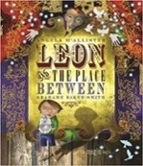  Leon and the Place  Between  Angela McAllister | 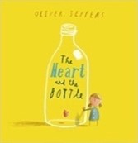  The Heart and the Bottle Oliver Jeffers |  | PSHCE  :  Grief | 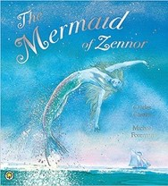  OR The Mermaid of  Zennor  Charles Causley |  | 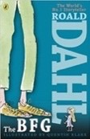  The BFG Roald Dahl |  | 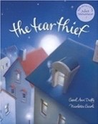  The Tear Thief Carol Ann Duffy |  | 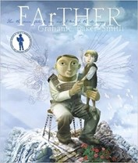  OR FArTHER  Grahame Baker  Smith |  | History:  WW 1
Length | 15 sessions, 3 weeks | 17 sessions, 3+ weeks |  |  | 15 sessions, 3 weeks |  | 15 sessions, 3 weeks |  | 10 sessions, 2 weeks |  | 15 sessions, 3 weeks
Outcomes | Own version fantasy narratives Persuasive posters, setting descriptions, thought bubbles/diaries, dialogue | Own version ‘dilemma’ narratives Character descriptions, narrative retellings |  |  | Own version legends  Information booklets, retelling from a different perspective, letters, tourist guides updates, dialogue |  | Own version fantasy narratives Recount (diary entry), character descriptions, wanted posters, new  chapters, instructions |  | Letters of explanation  Shared poems, persuasive posters, discussions |  | Sequel stories  Retellings, recounts (postcards), setting descriptions, diary entries, instructions
Theme/Term |  | Hope & hea | ling Spring | 1 |  |  |  |  | Overcoming ad | versity Spring 2
Planning  Sequence/  Spelling  Seed Text | 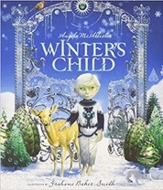  Winter’s Child  Angela McAllister | 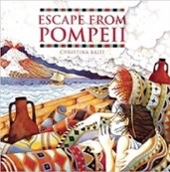 | Escape from  Pompeii  Christina Balit | History:  Ancient Rome | 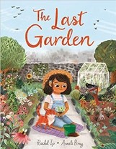  OR The Last Gard Rachel Ip | en | 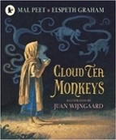  Cloud Tea  Monkeys  Mal Peet | 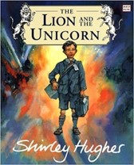 | OR The Lion and the Unicorn Shirley Hughes | 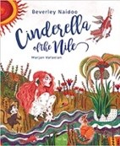  Cin the  Bev  Nai | derella of Nile erley doo | 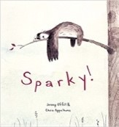  OR Sparly Jenny Offil
Length | 11 sessions, 2+ weeks | 16 sessions, 3+ we | eks |  | 15 Sessions, 3 weeks |  | 15 sessions, 3 weeks | 18 sessi | ons, 3+ weeks | 15 sessions, 3 week | s | 15 sessions, 3 weeks
Outcomes | Fantasy story sequels  Postcards (recount), dialogue, setting descriptions as letters, retellings | Newspaper reports Setting descriptions thought bubbles | , diaries, letters, |  | Own version extended narrative Setting descriptions, advertiseme  poster, retelling, instructional flyer, media updates, dialogue | nt/  social | Non-chronological reports  Descriptions, ‘how to’ guides  (instructions), letters, discussions | Own his  Letters, d and setti chronolo | torical narratives  iaries, character  ng descriptions, non-  gical reports | Own version narra Descriptive passage guides, letters, disc non-chronological r | tives  s, how to  ussions, eports | Own traditional tales Short news reports, diaries, character descriptions, adverts
Theme/Term | Fr | om mystery to d | iscovery Summe |  | r 1 |  |  |  | Pride & down | fall Summer 2
Planning  Sequence/  Spelling  Seed Text | 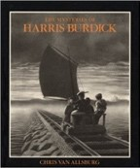  The Mysteries of Harris  Burdick  Chris Van Allsberg | 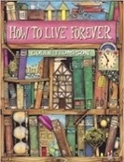  How Colin | to Live Forever Thompson |  | 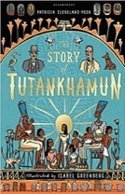  OR The Story of  Tutankhamun Patricia Cleveland-  Peck | History:  Ancient Egypt | 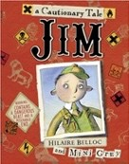  Jim, A Cautionary Tale Hilaire Belloc |  | 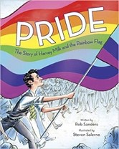  Prid  Har  Rain  Rob | e: The Story of  vey Milk and the  bow Flag  Sanders | 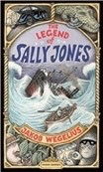  OR The Legend of Sally  Jones  Jakob Wegelius
Length | 15 sessions, 3 weeks | 15 sessions, 3 wee | ks |  | 15 sessions, 3 weeks |  | 10 sessions, 2 weeks |  | 10 sessions, 2 wee | ks | 16 sessions, 3+ weeks
Outcomes | Extended fantasy narrative  Setting description, short first person narrative, dialogue, speech, action scene | Prequels  Lost posters, letter character and settin instructions | of warnings,  g descriptions, |  | Non-chronological reports  Retelling, character description, b review | ook | Narrative poems  Warning posters, alternative endings, performance poetry, letter of apology |  | Biographies of Har Thought bubbles, s leaflets | vey Milk  peech, simple | Further adventure narratives  Birth certificates, letters, books of tricks, newspapers, adverts, diaries, leaflets, telegrams, booklets, goodbye notes
Ó The Literacy Tree

The Literary Curriculum Year 3/4 Curriculum Map Cycle B

2022/23
Theme/Term | Imagination & freedom Autumn 1 |  |  |  |  |  |  |  | Invention & transformation Autumn 2
Planning  Sequence/  Spelling  Seed Text | 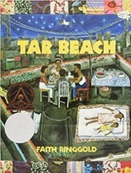  Tar Beach  Faith Ringgold |  | 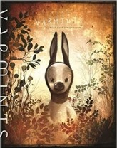  Varmints  Helen Ward |  | Science:  Lifecycles |  |  | History  :  Stone Age | 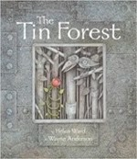  The Tin Forest Helen Ward |  | 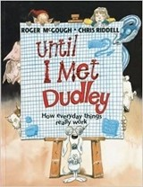  Until I Met Dudley Roger McGough  and Chris Riddell |  | Science:  Inventions
Length | 20 sessions, 4 weeks |  | 16 sessions, 3+ weeks |  |  |  |  |  | 10 sessions, 2 weeks |  | 10 sessions, 2 weeks
Outcomes | Own version playscripts  Character descriptions, formal letters, book reviews, dialogue (direct speech), retellings |  | Explanations  Descriptive comparisons, retellings, setting descriptions, poetry |  |  |  |  |  | Persuasive information leaflets Persuasive posters, information leaflets, postcards, diaries, wishes, setting descriptions |  | Two explanation texts - formal and informal  Letters, short explanatory paragraphs
Theme/Term |  |  | Leaders & foll | owers Spring 1 |  |  |  |  | Taking Cour |  |  | age Spring | 2
Planning  Sequence/  Spelling  Seed Text | 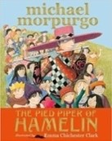  The Pied Piper of  Hamelin  Michael Morpurgo |  |  |  |  | 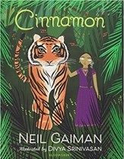  OR Cinnamon Neil Gaiman |  | Geography:  India | 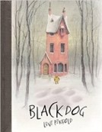  Black Dog Levi Pinfold | History:  WW2 | 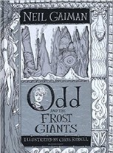  Odd and the Frost  Giants  Neil Gaiman |  | History:  Vikings
Length | 15 sessions, 3 weeks |  |  |  |  | 16 sessions, 3+ weeks |  |  | 15 sessions, 3 weeks |  | 15 sessions, 3 weeks
Outcomes | Own version myths/legends  Writing in role, information reports, adverts, formal letters |  |  |  |  | Own version mythical tales  Diaries, informal letters, dialogue, adverts, limericks and other poetic forms |  |  | Own version ‘suspense’ narrative Postcards, dialogue, retellings, descriptions | s | Retellings - alternative perspective Narrative recounts, character and setting descriptions, letters, short explanations
Theme/Term | Exploration & discovery Summer 1 |  |  |  |  |  |  |  |  | Fantasy worlds Summer 2
Planning  Sequence/  Spelling  Seed Text | 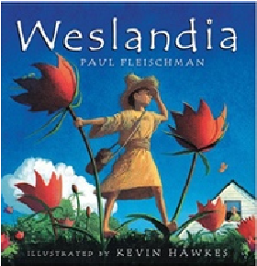  Weslandia Paul |  |  |  |  |  | 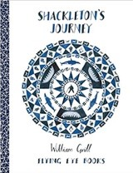  OR  Shackleton’s Journey  William Grill |  | 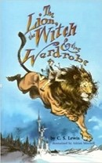  The Lion the Witch and the Wardrobe  C. S. Lewis | History:  WW2 | 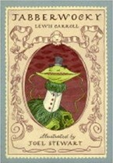  Jabberwocky  Lewis Carroll
Length | Fleischman15 sessions, 3 weeks | 15 sessions, 3 weeks |  |  |  |  | 15 sessions, 3 weeks |  | 20 sessions, 4 weeks |  | 10 sessions, 2 weeks
Outcomes | Imagined land narratives Character description, informative posters, persuasive leaflets, log book | Newspaper reports  Packing lists (justifications), letters (formal and informal), interviews, diaries |  | Sequels (mystery narratives)  Setting descriptions, narrative retellings, non-chronological |  |  | Tutankhamun Biographies  Reports, instructions, character descriptions, diaries, newspaper, posters |  | Own version narratives (set in other worlds)  Poems, eyewitness reports, an imaginary conversations, writing in role |  | Nonsense poems  Performance poetry, explanatory descriptions
Ó The Literacy Tree

