Taddington & Priestcliffe C of E (A) Primary School

Dove Holes Primary C of E Primary School
Peak Dale Primary School
SEND Information Report and complaints procedure for SEND provision
Who is who?
Name and Contact Details of the SEND Co-ordinator: Taddington
The SENDCo at Taddington and Priestcliffe C of E Primary School is Elaine Chapman, who is Head of School, a qualified teacher and is currently completing the National Award for SEN Co-Ordination.
Elaine Chapman is available on 01298 85278 or headofschool@taddingtonpriestcliffe.derbyshire.sch.uk. Please speak to Elaine if you have any questions regarding Special Educational Needs or would like to speak about your child.
Name and Contact Details of the SEND Co-ordinator: Dove Holes and Peak Dale Primary School.
The SENDCo at both Dove Holes CofE Primary School and Peak Dale Primary School is Natalie Doughty, who is a qualified teacher currently completing the National Award for SEND Co-ordination and is also the Head of School at Peak Dale.
Natalie Doughty is available on 01298 22695 or by emailing natalie.doughty@peakdale.derbyshire.sch.uk. Mrs Doughty works full-time between the two school sites. Please speak to Mrs Doughty if you have any questions regarding Special Educational Needs or would like to speak about your child.
The SENDCo and their areas of responsibility
Our SENDCos oversee and co-ordinate SEND provision for children with SEND.
- They support and guides staff and parents so that children with SEND have both high-quality teaching and ambitious support.
- They advise on the use of school’s SEND budget and resources to meet children’s SEND.
- They work together, and with the Executive Headteacher, to plan how we will enhance our SEND work.
- They identify training needs and make sure that SEND INSET enhances staff skills.
- They liaise with Early Years settings and other schools to help a smooth transition both in and out of our school.
- They act as the key contact for external SEND support services.

What is SEND?
A child has SEND if they have a learning difficulty or disability that we need to make special provision for. Some key terms explained:
• Learning Difficulty: when a child finds it harder to learn than most children do.
• Disability (that we need to make special provision for): something that hinders a child from using our school facilities.
• Special provision: is support that is extra or different to what is typically provided.

What are our Values?
Every child with SEND can thrive. We do everything that we can to make sure that happens. That means we:
• provide lessons that meet the needs of every child;
• make reasonable adjustments to lessons and our school environment;
• provide staff training to expand our SEND expertise.

What are our ambitions for children who have SEND?
We are ambitious for all children with SEND. We want them to make excellent progress. This means they will know more, remember more and be able to do more, despite their SEND. We want to give them the knowledge and skills they need for adult life. We think about both long term and short term. In the long term, we want our children with SEND to:
• have excellent basic skills (especially in reading, writing and maths)
• have good friends and relationships
• live a healthy and independent life in the community
• be successful in work

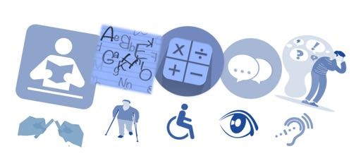
What are the four categories of SEND?

Schools follow the guidelines from the government’s SEND Code of Practice, where SEND is broken up into four categories:
- Cognition and Learning (C&L), including:
- Learning difficulties;
- Dyslexia & dyscalculia;
- Focus, attention or memory difficulties.
- Communication and Interaction (C&I), including:
- Autism / ASD;
- Social communication difficulties (other than autism);
- Speech & language difficulties (e.g. receptive language difficulties, selective mutism, tongue tie).
- Social, Emotional Mental Health (SEMH), including
- ADHD;
- ADD;
- Anxiety;
- Depression;
- Dysregulated behaviour.
- Physical / Sensory needs, including:
- Physical needs (e.g. cerebral palsy, developmental co-ordination disorder);
- Deafness or hearing difficulty;
- Blind or visually impaired.

Some children have more than one type of SEND. We welcome children with all of the above types of SEND who have applied for a place. If a child has complex needs, we consider admissions on a case by case basis (through an Education Health and Care plan consultation). For more information on this, please contact our SENDCo.

Identification of SEND
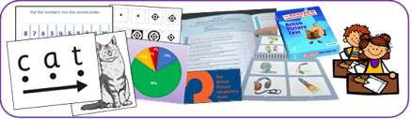

How do we decide if a child has SEND?
We will assess the child. This might be an assessment of reading, writing or maths. It could also be assessing a child’s social skills or behaviour. Some parents give us extra information to help us make decisions. For example, this could be an eye clinic report about sight loss, or an autism diagnosis letter. Sometimes our assessment might be quick. Sometimes SEND only becomes clear when we assess a child over a longer period.
When we assess, we always look out for:
• A child making less progress than their classmates;
• A child making less progress than they did before;
• A child not closing the gap between themselves and their peers (despite any extra help that we have given).
Sometimes, we ask outside experts to assess children and give us advice.
Is it always SEND?
Slow progress does not always mean a child has SEND. When we are assessing whether a child has SEND we also consider, for example:
• Attendance
• Issues in that child’s life (e.g. bereavement)
• Issues in school (e.g. friendships) Often teachers address progress issues via adjustments to what is already on offer, without needing SEND provision. A child does not have SEND just because English is not their first language (although they could have SEND as well). Also, a child doesn’t have SEND just because they were born in summer term (and so have had less time in school than their September born classmates).

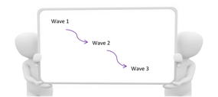
How do we meet children’s needs?

Children’s SEND are varied. Not all children need the same level of support. Where need is higher, we usually take more actions. Where need is lower, we might only need two or three adjustments. We match the level of support to the child’s level of need. This matching is called our graduated response. The levels of support are often called waves of support.
Schools have three waves of support:
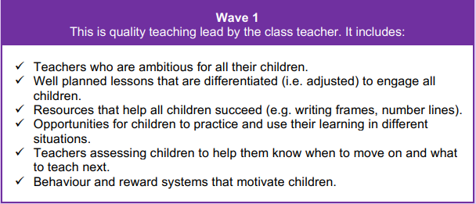
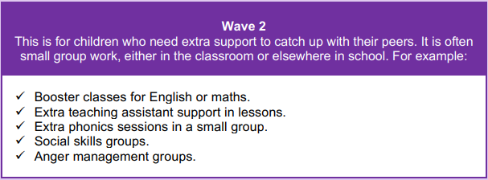
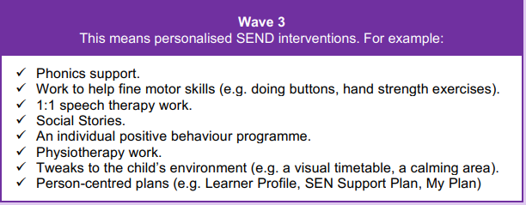
The SENDCo keeps a grid of our Wave 2 and Wave 3 SEND programmes. We call this our Provision Map.
Assess, Plan, Do, Review
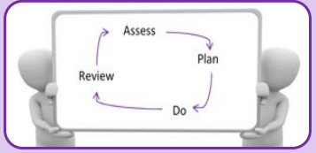
All our SEND support fits into a four-part cycle called Assess, Plan, Do, Review.
Assess: We decide what the child’s needs are.
Plan: We set targets. We decide how we support the child to meet these targets.
Do: Everyone follows the plans we’ve agreed.
Review: We look at how well the plans worked. We agree what to do next.
Each cycle takes one school term and there are three cycles per year. Sometimes this timescale is shorter (e.g. we are working on an important safety target or because the child is very young and is changing quickly)

Links with Support Services
The Federation has links with external support services in order to fully support children with SEN and aid school inclusion. These services include:
- Educational Psychology
- Health
- Speech and Language Therapy
- Teachers for the visually impaired
- Teachers for the hearing impaired
- Teachers for the physically impaired
- Physiotherapy, Occupational Therapy
- Behaviour Support Services
- Specialist outreach services- e.g. Autism Spectrum Disorder
- Social Care
- Multi agency teams

SMART Targets
We set targets for children with SEND so that staff, parents and children know what we are all working towards. These targets are part of a child’s SEND Support Plan or My Plan. We often call these SMART targets. SMART targets are:
Specific: We say exactly what the next small step will be for the child.
Measurable: We say how we will know if the child is meeting the target.
Achievable: We will be ambitious for the child, but it still needs to be achievable.
Relevant: We link it to the child’s difficulties or what they need to achieve next.
Time bound: Targets are normally set to for one term (10-14 weeks).
How are Targets Specific?
Specific targets say what the child will be able to do. We avoid words that are vague. Instead, we use action words to write targets (e.g. read, write, take turns).
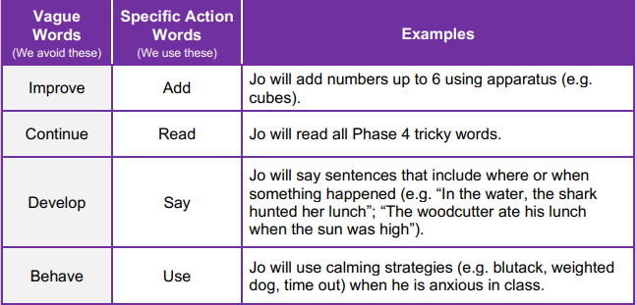

Working in Partnership with Parents and Carers
Teamwork with Parents and Families (For ease of reading, the word “parents” is used to mean anyone who has parental responsibility, including carers).

Parents are a vital to the success of children with SEND:
• Their knowledge helps us to get a complete view of a child's SEND.
• They tell us what strategies work well at home (often good ideas from home can help the child in school).
• Parents attend termly SEND Reviews so we can review their child’s progress as a team.
• Parents use ideas from school to help the child at home.
• Parents share useful information with us to help us meet the child’s SEND (e.g. clinic reports).

When we think a child might have SEND, we discuss this with parents. This is so that we can:
• Find out more about the parent’s views;
• Chat about what the next steps might be (this might include setting targets);
• Agree some long term goals (we might refer to these goals as outcomes). Excellent teamwork between us and parents is very important to us.
Co-Production
The word co-production means parents being a key part of planning SEND support and what’s provided for SEND. Co-production is really important to us. Parents help by coming to SEND reviews and giving their input or by keeping us up to date on their child’s life. Just as importantly, parents help us to improve our SEND support through our yearly parent survey, giving views on our latest SEND documents (parents helped us to produce this document) and giving ideas for our next parent workshops.

The role of the child
The role of children is to do their very best so that they learn more, remember more and can do more for the rest of their lives! It is also important that adults listen to the views of children with SEND. The child’s input can help us unlock extra progress. Collecting child views may include:
• Asking or observing the child.
• The child completing a survey.
• The child self-assessing their behaviour targets.
• The child coming to their SEND review meeting.
• An annual survey of SEND children. How we collect child views depends on the child’s age and development.

Can a child with SEND join in day trips, residential trips, breakfast, after school and holiday clubs?
Yes – we make adjustments so that children who have SEND can join in all of school life. Staff may need to talk to parents to plan adjustments. Or, a parent can talk to their class teacher or the SENDCo about if they are worried that their child might need adjustments to be successful. It is very rare that we have to make the hard decision for a child to not attend – in the very small number of occasions this is due to safety, wellbeing or both.

What do our teachers do for SEND?
Teachers are responsible for the development of every child they teach.
- Teachers work closely with support staff to plan and review support.
- Teachers adjust lessons to make them accessible for every child.
- Teachers use assessments to plan inclusive lessons.
- Teachers follow advice from any support services.
- Teachers review each child’s progress and plan the next steps.

What do support staff, including teaching assistants, do?
Support staff are a key part of our team.
- They help children reach for the stars.
- This includes supporting children during lessons and also leading both SEND groups and 1:1 work inside and outside of the classroom.
- Our SEND overviews long term plans for improving SEND in school. They monitor SEND in our school. This includes our legal duties. They meet with the SENDCO three times a year.

How do our team develop their SEND Expertise?
Our team have lots of SEND expertise. However, it is important we refresh and develop our learning and further develop our skills. To train and develop our team, we use:
- Staff meeting and INSET day training Staff supporting each other Online courses and webinars e.g. MindEd: www.minded.org.uk
- Online information e.g. NASEN’s What Works: https://www.wholeschoolsend.org.uk/page/what-works

What training have we had?
In the last three years, members of our staff team have had training on:
- Read, Write Inc / Little Wandle Phonics
- Engagement Model
- Fischer Family Trust
- Reading comprehension for children with SEND Social Skills and Language
- Autism
- Lego therapy
- NIP and VIP
- Adverse Childhood Experiences
- Anxiety
- Attachment
- The Sheffield Support Grid
- Positive behaviour support for ASD
- Sensory Processing

Curriculum Accessibility for SEND
Within the Federation, we strive to be as inclusive as a mainstream school can be.
Our whole-school inclusive ethos means that we put SEND at the centre of our overall approach to school. This includes:
- The school day structure
- The learning environment
- The teaching and learning techniques and strategies used
- The scaffolding of learning so all children can reach a similar outcome
- Use and planning of resources to maximise access to school and learning
- The whole-school approach to managing behaviour
This is all underpinned by the mindset of leaders and teachers that high-quality provision for SEND is high-quality provision for all.
As an inclusive school, we do all that we can to ensure that children with special education needs and disabilities can access the curriculum fully.
In order to achieve this, any of the following strategies may be used:
A multi-media approach – videos and images are used as stimulus in lessons so that children can access the learning, regardless of reading ability. If a child has EAL, translations are used where possible.
Visuals – we use visuals, where appropriate to ensure that children can access, particularly if vocabulary is a barrier to the learning
Pre-teaching of vocabulary – where new vocabulary is introduced, children with SEND may be introduced to this prior to the lesson to increase their opportunity of understanding at the point of the main teaching.
Flexible Groupings – children will learn in mixed-ability pairs or groups, allowing children to support each other. Research identifies that children can deepen their own understanding by explaining to someone else.
Recording of learning – this can often be a barrier to SEND children’s learning – we therefore adapt the recording methods to mitigate this barrier. This may include, using more pictoral representations when recording, using cloze procedures or using technology, such as ‘Clicker’ for those with significant writing barriers.
Paired and group discussion – this is used to allow children to learn from each other and to share understanding in a less challenging way – often children with SEND lack confidence to share to a whole-class.
Differentiating texts – when texts are used, children with SEND sometimes find it challenging to access age-appropriate texts. Staff therefore may produce simplified texts for SEND children to read.
Additional use of technology – other technology, such as iPads or sound buttons may be used to hold questions and ideas for the children before recording.
SEMH support - children with SEMH may find it challenging to access learning content in some subjects, due to personal difficulties they may be having that relate to the lesson being taught. In these circumstances the teacher can liaise with the school’s pastoral lead to run sessions with these children to emotionally prepare them before the lesson takes place.
Many of these strategies will be used at a whole-class level and some may be used on a more targeted basis to further support and increase access to the curriculum.
Support Services for Parents
The Independent Advisory Service: ias.service@derbyshire.gov.uk
Telephone number: 01629 533668
Useful links
Schools websites: www.taddingtonpriestcliffe.derbyshire.sch.uk / https://www.peakdale.derbyshire.sch.uk/ https://www.doveholes.derbyshire.sch.uk/
Derbyshire Local Offer: www.derbyshire.gov.uk/SEND
SEND Code of Practice: https://www.gov.uk/government/publications/send-code-of-practice-0-to-25
On the School website there are links to all the school’s other policies, including accessibility, safeguarding, anti -bullying and behaviour which all link closely with this policy.

Complaining when the school is not using its best endeavours to secure special educational provision for a child with SEN

What should the nursery/school/college be doing?
The ‘appropriate authority’ for the setting (the school governors or equivalent) has a legal duty to use their ‘best endeavours’ to secure special educational provision for all children and young people with SEN for whom they are responsible. This applies whether or not the child/young person has an EHC plan. It does not apply to independent schools.
Children and young people without an EHC plan should receive SEN Support. See the section on how your nursery, school or college should help for more information.

When should I complain?
You should speak to the class teacher and SENCO about your concerns and ask them to discuss the implementation of SEND Support with you.
If your child still doesn’t receive the support they need, you may wish to make a complaint.
If your child has an EHC plan and the setting is not delivering the special educational provision specified in the plan, you should raise this initially with the school SENDCo , the Head of School and if your concern or complaint is not resolved , the Executive Headteacher.
Complaints, if not resolved will be escalated to the governing board. Should matters be unresolved at this or at any other point you may wish to make a formal complaint to the Local Authority.
You should follow the school’s internal complaints procedure – details can be found on the school websites.

